

MUUGLines
The Manitoba UNIX User Group Newsletter
Volume 38 No. 1, September 2025 Editor: Trevor E Cordes
Next Meeting: September 2nd, 2025 7:30pm
In Person and Online
NEW
LOCATION

MUUG is moving to a new location to start the new season. Winnipeg Senior Citizens Radio Club (WSC) has graciously offered to host MUUG meetings going forward. Several current and past MUUG members are also members of WSC. MUUG President Wyatt Zacharias will be our WSC liaison and duty officer.
WSC is located at 598 St. Mary’s Road, 2nd Floor, a block South from the St. Mary’s / St. Anne’s fork, on the West side beside the Miller’s Meats. It’s in the old fire hall, so you really can’t miss it! Look for the red doors.
The meeting space is on the 2nd floor and there is no elevator, so attendees will have to be able to climb a flight of stairs. Apologies to anyone requiring accessibility. It is also possible to attend via online videoconferencing (see below).
There are a limited number of parking spaces for WSC around the building. If you arrive early you’ll probably snag one. If not, there is parking available on the nearby streets, such as Mager Dr, or the streets off of St. Mary’s such as Blenheim or Clonard Ave. Be careful not to park in nearby private parking lots unless otherwise indicated.
Many thanks to MUUG Treasurer Brad Vokey and Fortress Software Inc. for hosting the MUUG meetings since the covid lockdowns – over two years! It is not as easy a job as it may seem (lookin’ at you Steve!). (Fortress Software has moved and the new location is not as amenable to MUUG meetings.)
Main Presentation – Kopia
Alberto Abrao will present and demo Kopia, a “Fast and Secure Open-Source Backup Software” solution. Kopia provides GUI and CLI on multiple platforms (Windows, macOS, and – of course – Linux), to make encrypted, compressed and dedup’ed backup to the cloud storage of your choice.
RTFM: /bin Diving
If time permits, we will also be taking a dive into the /bin, with this month’s host Trevor Cordes.
/bin Diving is our segment where we pick a random program in /bin to demo and discuss and learn about as a group. It’s improv at its best!
Where to Find the Meeting
We are continuing to meet on the first Tuesday of every month. You can attend in person or online via videoconference.

Beverages and cookies or treats will be provided. Pop for sure… Hot beverage options are TBA.
Doors will open by 7:15pm. Meeting starts at 7:30pm.
To attend in person, see the “New Location” section on page one.
To attend online, check and refresh the following link after 7:15pm. There is no need to create an account in BBB, nor login. Just enter any name as your screen name and hit join.

https://muug.ca/meet

The latest meeting details are always at:

https://muug.ca/meetings/
Door Prizes: Welcome Linux Mag!
Linux Magazine is the longest-running physical/printed Linux magazine in the world – especially when you take into account its 2008 acquisition / continuation of the USA-based Linux Magazine. It is now Germany-based, run by Computec Media GmbH, with the English edition run by Linux New Media USA.
Linux New Media has graciously offered MUUG a special deal to acquire a copy each month to give away as a door prize for our members. Thanks Linux Mag!

https://www.linux-magazine.com/
Come out to the next meeting to flip through the large-format, glossy mag to see what it has to offer. Sign up for the door prize draw and you can win the chance to take it home.
There are also a couple of newer batches of e-books you may want to peruse as a possible door prize choice this month.
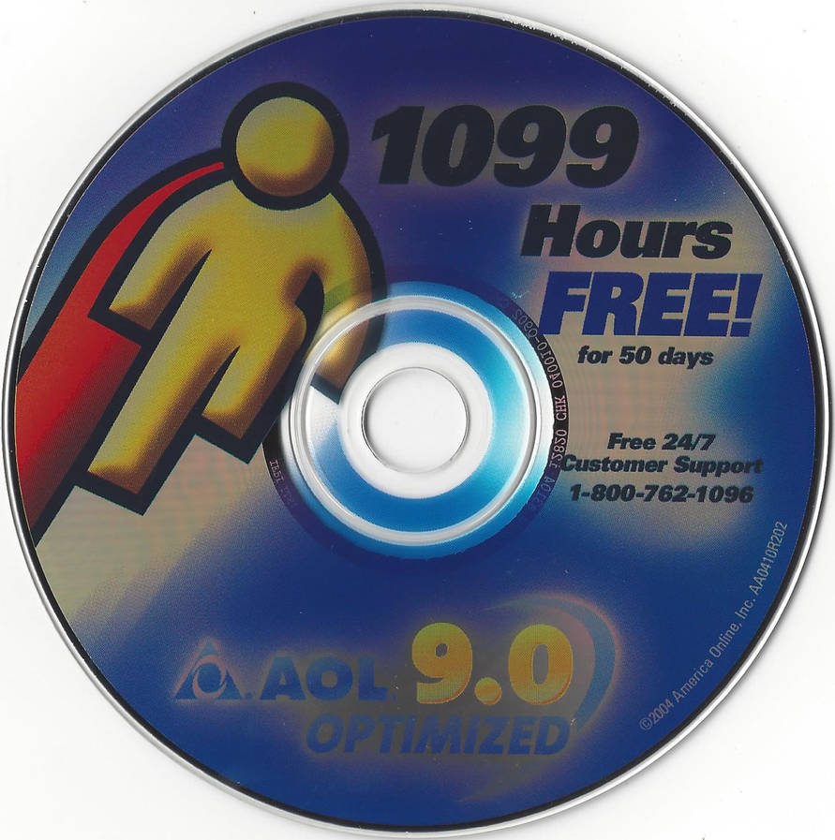
And, as usual, one lucky winner can select an e-book graciously donated by Michael W. Lucas of Tilted Windmill Press (see advertisement on last page).
Everyone is encouraged to enter the door prize draw: both in-person and virtual attendees. You don’t have to be a member to enter, but members have exclusive access to the first draw. Members also get the privilege of not having to be present (physically or virtually) for the draw in order to claim their non-physical prize. However, physical prizes can only be selected by in-person attendees. If you attend online you’ll have to select from one of the e-books if you win a door prize.
MUUG Mirror Update
The mirrors… they do grow. The mirror on your muug.ca group server filled up once again. Too many distros growing too big too rapidly.
MacPorts had to be sacrificed at the Altar of Spinning Rust. (Alas, no blessed named object appeared.) A study of overall mirror usage showed that MacPorts was infrequently accessed relative to its weighty disk usage (1.9TB).
Past sacrifices included OpenEuler and Project Gutenberg, both for similar reasons of space versus usage. “Pertinence to UNIX and MUUG” are also taken into consideration when deciding what gets the axe. As does “do they have another Canadian mirror”.
Absent a very pricey, many-SAS-disk upgrade, MUUG will probably be forced to delete one mirrored distro every year or so. MUUG currently hosts over 50 distros/projects.
The largest distros currently hosted on the server are:
7.1TB opensuse
5.2TB ubuntu-ports
3.6TB ubuntu
3.0TB fedora
2.1TB ubuntu-cdimage
2.0TB debian
2.0TB ubuntu-cloud-images
1.6TB openbsd
1.4TB linux kernel
1.3TB fedora-secondary
1.2TB rocky
Tsk tsk opensuse! What are you doing?! And ubuntu all combined into one… Yikes!
As an interesting aside, ZFS handled 99.99% full much better this time than last time. Perhaps improvements were made? The box was actually still usable. Winning!

https://muug.ca/mirror/
GCompris Spricht Deutsch
Children’s game / educational tool gcompris, reviewed in the March 2024 MUUGLines, now expanded language support. It has full or near-full support for most major languages; 44 languages in total.
Besides Linux support, it’s also now available for Android, iOS, and Windows. However, some sub-games don’t work well with touch-only interfaces, so the best experience is still on a desktop OS.
Cool PHP: mb_strcut
Every programmer has used substr(), almost universally available in every language – though often with different nomenclature. It allows you to cut a substring of a specified number of bytes (characters) out string.
But then UTF (et al) came along and now bytes weren’t necessarily characters anymore (or vice versa), because each character could now be 1, 2, 3 or 4 bytes. This isn’t your dad’s ASCII, and we aren’t (just) in Kansas anymore.
So PHP added mb_substr, just like they did all the other mb_* functions: “substr on multi-byte (mb) strings”. Instead of extracting a certain number of bytes, it extracts a certain number of (usually-)UTF-8 characters. It worries about multi-byte boundaries so you don’t have to, and you’re guaranteed to get a valid UTF-8 string out of it.
But there’s a problem: whilst substr returns a known number of bytes. mb_substr does not. If you tell it to extract 4 characters, you could end up with a string that is 4 bytes long, or 16 bytes long!
Sometimes you just really need to know you won’t get over a certain number of bytes, and ensure you still get a valid UTF-8 string. If you just extract byte-wise with substr, you could chop a 4-byte multi-byte UTF-8 character in half. The result, if displayed to a human, could/would be a trailing gibberish character, much like when you try to display 8859 Latin-1 as UTF-8 (been there, done that).
mb_strcut solves this problem by taking the specified length (et al) to be byte counts, just like the original substr. But it adds in the secret sauce of “understanding” the underlying multi-byte character encoding. If a cut position byte is inside a multi-byte character, then the cut is made from the first byte of that character.
What this means in practice is you are guaranteed to get a string that is equal to or less than the number of bytes you specified (as the length) and it will still be a valid UTF-8 (or whatever encoding) string. Very handy indeed!
substr("Déjà vu",0,2) → d� (2B)
mb_substr("Déjà vu",0,4) → Déjà (6B)
mb_strcut("Déjà vu",0,5) → Déj (4B)
AOL Ditches Dial-Up
Huh? They were still around?
Yes, AOL, the famous “you’ve got mail”, new-coaster-every-month-in-the-mail company was still doing dial-up. You know, 56k v.90 (NOT “bis”!) swoosh bing bleep bleep.
As of September 30th 2025, the bings bongs and blinkenlights will blink no more. That’s when AOL turns off the last of its dial-up infrastructure. On that date, 163,000 people in the USA who claim they still use dial-up will be left internet-less... or forced into the wild world of 2000. <Elon hand-wringing intensifies?>

https://www.aol.com/end-era-aol-discontinues-dial-193114696.html
Brave Blocks MS’s Recall
Brave Browser, an alternative privacy-centric web browser, beat everyone to the punch and by default blocks the relatively new “really useful and ultra-safe” Microsoft Windows 11 “feature” Recall when using Brave.
If you didn’t know, Windows 11 is taking a screenshot of your desktop very few seconds and sending them to who knows where. You know, like your private banking information, passwords, naughty things…
Sure, Microsoft added the ability to disable Recall (they pinkie swear, super cereal!), but 99% of the world won’t bother. Of course, 99% of the world isn’t using Brave Browser… but for those lucky few, worry not, for Brave was protecting you all along! And if you like the idea of never seeing an ad and having ultimate privacy and security, give Brave a try (and its separate web search engine search.brave.com).
A big thanks to Les.net for providing MUUG with free hosting and all that bandwidth! Les.net (1996) Inc. is a local provider of VoIP, Internet and Data Centre services. Contact sales@les.net by email, or +1 (204) 944-0009 by phone.
Help us promote this month’s meeting, by putting this poster up on your workplace bulletin board or other suitable public message board:

https://muug.ca/meetings/MUUGmeeting.pdf
Thanks to Linux Mag for providing MUUG a half price magazine subscription for our door prizes.
Linux Magazine is your guide to the world of Linux and open source. Each monthly issue includes advanced technical information you won’t find anywhere else including tutorials, in-depth articles on trending topics, troubleshooting and optimization tips, and more! Subscribe to their free newsletters and get news and articles in your inbox.

https://www.linux-magazine.com/
MUUG would like to thank Michael W. Lucas for donating one of his ebooks every month as a door prize. You can view and purchase his tech books here:

https://www.tiltedwindmillpress.com/product-category/tech/
Except where otherwise noted, all textual content is licensed under a Creative Commons Attribution-ShareAlike 4.0 International License.

https://creativecommons.org/licenses/by-sa/4.0/

