


MUUGLines
The Manitoba UNIX User Group Newsletter
Volume 37 No. 6, February 2025 Editor: Tyhr Trubiak
Next Meeting: February 4th, 2025, 7:30pm In Person and Online
Feature Presentation:
My Favourite Browser Plugin(s)
by Trevor Cordes
This month we return our focus to the desktop by discussing and demonstrating a couple of Trevor Cordes’ favourite browser plugins. Yes, there are a million of these things, and everyone has their own set of “indispensables”. The choice often comes down to what itch you have to scratch, and what cool ones you’ve been introduced to by friends – or MUUG.
Wait a minute...this feels like déjà vu.... wasn’t this advertised in the November newsletter and then had an emergency cancellation?
Yes.
I understand that we did no presentations in the festive December holiday meetings, but wasn’t this also promised to be presented in the January meeting?
Again, yes. Trevor was in attendance and fully pre-pared to present. However, due to time restrictions (due to Kevin’s very successful presentation), it was agreed that Trevor’s Favourite Browser Plugin(s) presentation will be done in February’s meeting, as this is an eagerly anticipated unveiling worth waiting for.
So now we really, really promise that we won’t cancel Trevor’s presentation at the last second!
Pinky swear!
Third time is the charm!
Trevor personally hates clutter in web pages he frequents. So he’ll show you how to clean things up with ABP and uBlock Origin. But we’re not just talking ads: nope, you can remove basically any piece of nonsense on any site with a bit of extra work. You’ll see the easy “anyone can do it” way plus the “completely insane” complex way – including when sites purposely try to sabotage your blockers. Winning!
Trevor may also discuss/demo NoScript, Dark Reader and Video Background Play Fix: all things he cannot possibly live without. If you don’t leave wanting to install a few of these then you must be from outer space!

If you show up in person, you will be treated to more beverage choices than we’ve offered in over a decade: coffee, tea, and pop, as well as various chocolates and cookies. And parking is free, copious, safe, and just a handful of feet from the door.
Please stay home if you are sick that day.
To attend via internet, check and refresh the following link after 7:00pm. There is no need to create an account in BBB, nor login. Just enter any name as your screen name and hit join.

https://muug.ca/meet

The latest meeting details are always at:

https://muug.ca/meetings/
Where to Find the Meeting
We are continuing to meet on the first Tuesday of every month.
Fortress Software Inc.
350 Keewatin St – Unit #2
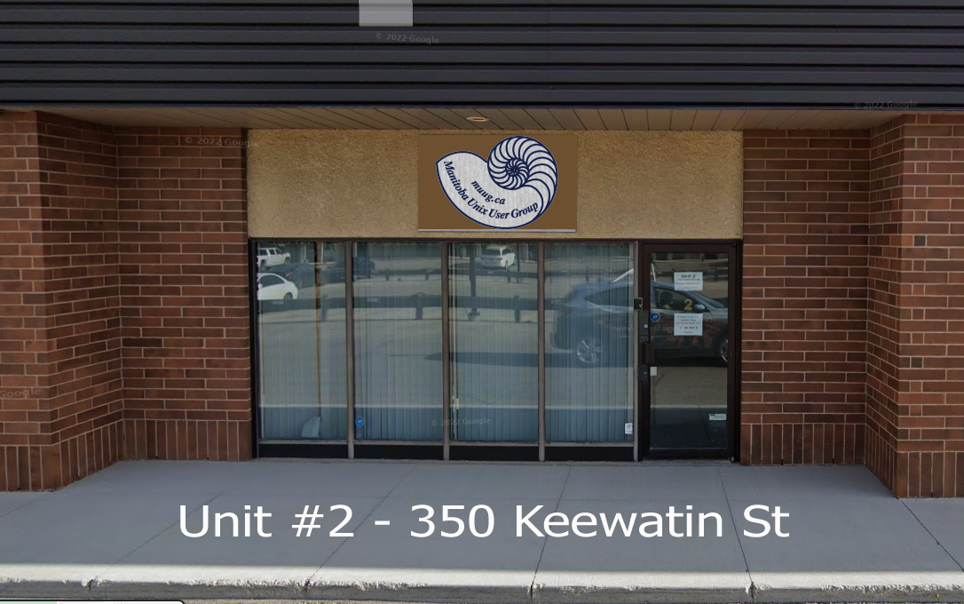
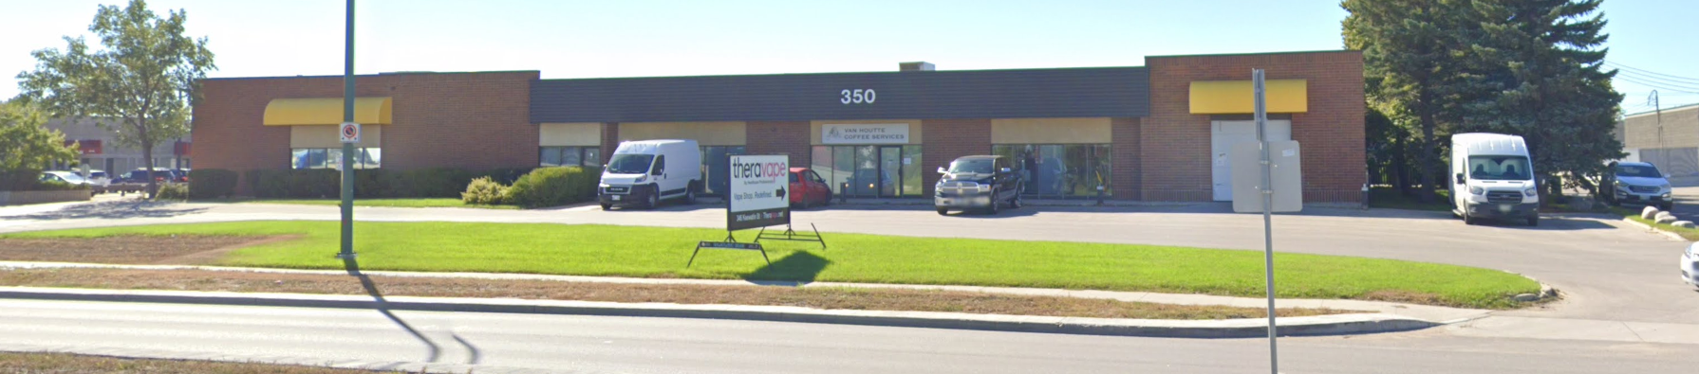
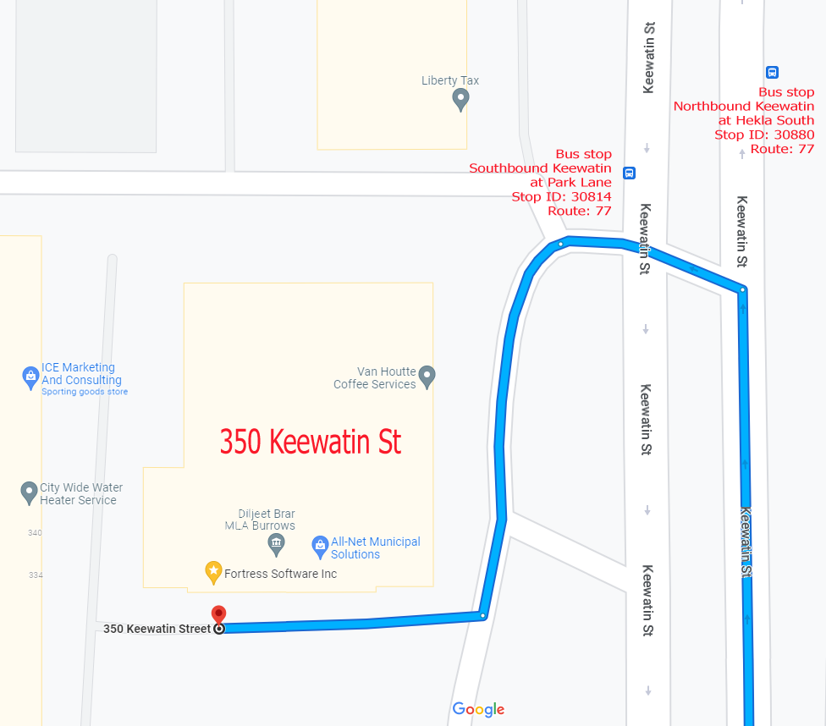
Doors will open at 7:00pm. Meeting starts at 7:30pm.


If driving, enter the lot using the most north-eastern entrance (far right in the top picture) and drive around to the south west corner of the building (see route in map detail). You can use any of the free, ample, and safe parking spots that say “reserved” or “MUUG” in front of units #1 through #4 before entering into unit #2. Look for the sign over the door!
Bus stops #30814 and #30880 (route 77) are only 150 meters away. The last bus leaves for Polo Park at 10:15 pm and for Garden City at 10:31 pm. Logan Ave. bus routes #19, #26, and #27 are a 600 meter (8 minute) walk to the south.
Rsync is vulnerable!
There were 6 CVEs found in rsync made public on January 14. A fixed version came out the same day (the vulnerabilities were actually known in early December), and was further tweaked for better compatibility the following day.
Rsync is a very popular tool. MUUG uses it to host various Linux repos to the world. We also had it patched on the same day thanks to our stalwart server team volunteers.
Rsync synchronizes two copies of an arbitrarily large file across a relatively slow connection without resending all the contents of the file across the line, which is a very useful thing when it comes to the distribution of data, and one of the reasons it is installed on so many servers.
One of the vulnerabilities has a CVSS severity score of 9.8 out of 10, and the description says:
“an attacker only requires anonymous read access to a rsync server, such as a public mirror, to execute arbitrary code on the machine the server is running on.”
This affects all versions of rsync since version 3.2.7 in October 2022.
The severe one is a heap buffer overflow in rsync due to improper checksum length handling, and the next two also relate to checksums – info leak via uninitialized stack contents (but it’s just one byte), and the rather more worrying leaking of arbitrary client files. The next two are a path traversal vulnerability and safe-links option bypass leads to path traversal.
A big thanks to Les.net for providing MUUG with free hosting and all that bandwidth! Les.net (1996) Inc. is a local provider of VoIP, Internet and Data Centre services. Contact sales@les.net by email, or +1 (204) 944-0009 by phone.
MUUG would like to thank Michael W. Lucas for donating one of his ebooks every month as a door prize. You can view and purchase his tech books here:

https://www.tiltedwindmillpress.com/product-category/tech/
All of these were reported by the same team of Google security researchers – Simon Scannell, Pedro Gallegos, and Jasiel Spelman. The final one, race condition handling symbolic links, was found on December 18 by Russian pen-tester Aleksei Gorban, a Kaspersky veteran who now works for TikTok.
The others are all less severe, in the 5.6-7.5 range, but they’re all as old as rsync itself, which dates back to 1996.
5 Lightweight Linux Distributions to Bring Your Old PC Back to Life

Jack Wallen gives us his top 5 pics for a lightweight Linux distribution. The choices were limited to those whose system requirements are equal to or less than a 1GHz CPU, equal to or less than 2GB of RAM, and a minimum of 10GB storage.
1. Linux Lite
Linux Lite is possibly the best of all lightweight Linux distributions in Jack’s opinion. Based on Ubuntu LTS and designed with user-friendliness in mind, Linux Lite uses the Xfce desktop to create a UI that’s clean and simple but doesn’t miss out on features.
Once installed, you’ll find Linux Lite includes the apps you need to get started, such as Chrome, LibreOffice, GIMP, Photo Manager, Deja Dup Backups, VLC media player, a USB image writer, an onscreen keyboard, Timeshift (for restore points), and more. If it doesn’t include the app you need, there’s always the Synaptic Package Manager GUI to help you find what you’re looking for.
The system requirements for Linux Lite are:
CPU: 1GHz or faster
1GB of RAM
8GB of drive space

2. AntiX
AntiX is another lightweight distribution, but not recommended if you are new to Linux. AntiX is geared more toward those with at least a bit of Linux experience. The reason for that is AntiX opts for the zzzFM-IceWM window manager, which is not quite as simple as KDE Plasma or GNOME.
AntiX ships with plenty of pre-installed apps, such as Firefox, LibreOffice, Firejail, plenty of media players, and more. AntiX is crazy fast! It puts the afterburners back in an old computer...as long as you can live with window manager.
The system requirements for AntiX are:
CPU: Intel Core 2 Duo or AMD Athlon 64 X2
1GB or more RAM
10GB or more drive space
Graphics: Any graphics card with 3D acceleration

3. Bodhi Linux
The Moksha Desktop is a fork of Enlightenment, and it looks gorgeous. Of all the lightweight distributions, Bodhi is, by far, the most unique. Unique, but very easy to use.
One of my favourite features of Bodhi Linux is the right-click mouse menu. Right-click anywhere on the desktop, and a menu will appear where you can launch applications and much more. The right-click menu is the same as the desktop menu, so it’s very efficient. Although Bodhi Linux doesn’t include much in the way of eye candy, you’ll find plenty of beautiful themes to choose from.
The Bodhi Linux system requirements are:
CPU: 1GHz or faster
768MB of RAM
10GB of drive space

4. BunsenLabs
BunsenLabs Linux will surprise you with how it is functional and user-friendly. On top of that, it’s beautiful. This distribution is a continuation of the beloved CrunchBang Linux and uses a Debian base, the OpenBox window manager, the tint2 panel, Conky, and jgmenu. All of those bits come together to form a lightweight Linux distribution that not only performs incredibly well but looks very modern.
On top of all this, it shouldn’t take you any time to get up to speed with how the distribution works. Even better, BunsenLabs Linux includes a desktop mouse menu that is similar to the one found in Bodhi Linux.

The system requirements for BunsenLabs Linux are:
CPU: 1GHz or faster
2GB of RAM
20GB of drive space

5. Lubuntu
Lubuntu is another distribution based on Ubuntu LTS, and the only one on this list that the editor has experience with. However, Lubuntu uses the LXQt desktop, which is one of the most full-featured of all the lightweight desktop environments. LXQt is very fast and easy to use. Lubuntu is an official spin of Ubuntu and retains things like Snap package support, a stable kernel, a similar set of pre-installed software, and access to the standard Ubuntu repositories.
And although the Lubuntu desktop may give you early-2000s vibes, that doesn’t mean it’s too old-school for use. Lubuntu even includes KDE Plasma’s Discover app store, so you won’t have any problem installing all of the apps you need. The best thing about Lubuntu, however, is the speed. This lightweight Linux distribution will blow you away with how fast it runs, even on older hardware.
The system requirements for Lubuntu are:
CPU: 1GHz or faster
1GB of RAM
5GB of drive space
Android 16 might include a Terminal and full Linux VM support with GPU acceleration
A native terminal app for Android has been in the testing phases, and could be released with Android 16, which is expected in the 2nd quarter of 2025. The Terminal app will allow installation of a Linux VM with full GUI and GPU acceleration along with other sysadmin features including disk resizing, port forwarding, partition recovery, snapshot backup and restore, nested virtualization, and support for x86_64 devices.
Yes, Chromebook users have had the ability to install a Linux virtual machine (VM) for a while, and this is an extension of that, using the Android Virtualization Framework.
The Android Runtime (ART) is based on a Linux kernel, with plans to give users the flexibility to run a full Linux desktop.
This magic is made possible due to the Android Virtualization Framework (AVF) that was first introduced in Android 13. In Android 15, AVF gains the ability to run GUI operating systems in a VM with full GPU acceleration.
Terminal emulator apps that provide a Linux environment have been available in the Play Store, but Google’s implementation will be integrating the terminal directly into Android, allowing the Terminal app to run a full Linux distro in a VM and interfaces with it via a local IP address to pass Linux commands from the Android host.
It is not clear at the moment whether this feature will make its way to OEM-specific ROMs, but at least Pixel devices can be expected to offer support.
Except where otherwise noted, all textual content is licensed under a Creative Commons Attribution-ShareAlike 4.0 International License.

https://creativecommons.org/licenses/by-sa/4.0/

