
MUUGLines
The Manitoba UNIX User Group Newsletter
Volume 33 No. 10, June 2021 Editor: Bradford C. Vokey
Next Meeting: June 8th, 2021
(Online Jitsi Video Meeting)

Topic: Introduction to PeerTube
A Free and Decentralized Video Hosting Platform – Chris Audet

The internet continues to trend towards large, corporate owned websites and platforms. No one can deny that large platforms are amazing and convenient! But due to their sheer scale, social networks have difficulty with moderation and preventing abuse. Rules that work well for one set of users might be unacceptable to others, and automated moderation tools perform poorly outside of the culture and language they were developed in.

These concerns have encouraged a wave of federated, decentralized social networks, loosely labelled the “fediverse.” Similar to how email servers work today, any admin can run an instance of a social network, which then associates with other servers to share content and hosting costs.
PeerTube is the most popular federated video hosting platform in this space, with an active community and many instances.
Join us this month, as Chris Audet explores a possible future direction for video driven social networks. Chris will discuss why you might want to host a PeerTube instance, the cool underlying tech, and the role of alternative social networks in a world dominated by giants.
Where to Find the Meeting:

jitsi.merlin.mb.ca/muug.2021.06

This month (just like last month) we are using our own online Jitsi meeting server hosted by merlin.mb.ca.
The virtual meeting room will be open by 7:00 pm on June 8th, with the actual meeting starting at 7:30 pm. You do not need to install any special app or software to use Jitsi: you can use it via any modern webcam-enabled browser by going to the aforementioned link. No camera? Join without, or use your phone with the Android or iOS app!
After joining the meeting, please:
- Keep yourself muted (or stay quiet) while others are speaking.
- Update your screen name from Fellow Jister to your actual name (click on your video thumbnail to edit your name).
- Use the chat function to get help if you need it.

Thank you MERLIN (the Manitoba Education Research and Learning Information Networks) for providing the hosting and bandwidth for our meetings.
June Door Prizes:

As usual, thanks to Michael Lucas, we will be giving away one Michael W. Lucas “Mastery” title e-book of your choice: https://www.tiltedwindmillpress.com/product-category/tech/
We’ll also be giving away 2 to 3 of our usual assortment of e-book giveaways:
https://muug.ca/dpview.php
^grex$
A simple command line tool to generate regular expressions
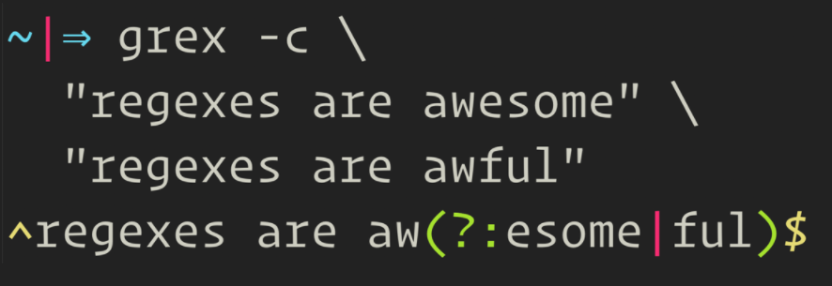
grex is a library as well as a command-line utility that is meant to simplify the often complicated and tedious task of creating regular expressions. It does so by automatically generating a single regular expression from user-provided test cases. The resulting expression is guaranteed to match the test cases which it was generated from.
This project has started as a Rust port of the Java Script tool regexgen written by Devon Govett. Although a lot of further useful features could be added to it, its development was apparently ceased several years ago. The plan is now to add these new features to grex as Rust really shines when it comes to command-line tools. grex offers all features that regexgen provides, and more.
The philosophy of this project is to generate the most specific regular expression possible by default which exactly matches the given input only and nothing else. With the use of command-line flags (in the CLI tool) or preprocessing methods (in the library), more generalized expressions can be created.
The produced expressions are Perl-compatible regular expressions which are also compatible with the regular expression parser in Rust's regex crate.
Board member Adam Thompson posted this tool to the board mailing list as a possible RTFM topic.
Trevor Cordes replied with:
“Cheating! However, if it does optimization on repeated prefixes as it appears... it could be useful. I might throw my 2MB regex at it to see what happens...”
To which Adam replied:
“I feel that if your regex is 2MB, you're well into “now you have two problems” territory.
In fact I think you crossed the state line a long time ago...”
Rocky Linux 8.3 RC1 released
On April 30th, Gregory Kurtzer, the originator behind the now dead CentOS released the first release candidate of Rocky Linux.
Jack Wallen in a TechRepublic article took it for a test drive...
“If I didn't know the new Rocky Linux ISO image was a release candidate (RC), I'd have thought it to be a final release. For all the warnings, the Rocky Linux RC is remarkably stable and gives us a clear view of what's to come from the original creator of CentOS.”
Rocky Linux is taking the same approach to updates as CentOS did—slow and methodical. Because Rocky Linux aims to be a downstream release of RHEL, you can be sure it'll serve as a 1:1 binary replacement for Red Hat's flagship (what CentOS used to offer).
“One of the best things about installing Rocky Linux is that it felt so familiar—as though I'd been transported back in time, to a moment before CentOS getting swept down the stream on a raft made of drama. Everything worked exactly as expected and not one thing caught me off guard. If you've deployed CentOS to your data centers, you'll find Rocky Linux to be the same as it ever was.”
Jack also has a good review of AlmaLinux (another CentOS replacement).
$1,000 worth of Free Credit Card Processing!

Sign up with Square (the credit card processor that MUUG uses at our monthly meetings) with the referral link below and both you and MUUG will receive $1,000 in free processing for the next 6 months (180 days).
You must use the following referral link for MUUG to receive the credit:

https://squareup.com/i/MANITOBAU1
Goodbye screen(1) – Hello tmux(1)

By Troy Denton and Brad Vokey
Fellow board member Troy Denton has recently changed employers, and was thrilled to find a proliferation of high-powered Linux systems at his new workplace – wow what a joyous day! But wait – what’s this? – they didn’t all feature the screen(1) terminal multiplexer from 1987 that Troy had been stubbornly using – according to his own words – “for no reason at all.” He clarified that his workflow simply wasn’t broken, so like the rest of us, there was no reason to change it. So, lamenting over his lack of admin rights to install screen(1), he decided to take the available tmux(1) for a spin. Within an hour he was making splits, navigating sessions, and ended up preferring tmux to screen very quickly.
At around the same time, your current newsletter editor, Brad Vokey, also started using tmux(1) to keep his remote server sessions alive, accessible, and shareable from multiple different computers and have it all survive server and workstation log-outs and even server reboots. Now he can go ahead and reboot his servers into that fresh new what-seems-like-monthly kernel updates (thanks Fedora) without losing all his current terminal sessions, set-ups, and custom layouts!
Vaccinated Geeks

https://xkcd.com/2460/
Here are a few of their quick key takeaways:
- Create a tmux session with the name “foo”: tmux new -s foo
- Once you are in a session, you interact with tmux using a <prefix> key, which by default is Control-b. This default prefix conflicts with bash’s built-in cursor control (C-b for “move back one word”) but with tmux (unlike screen) you can just repeat the <prefix> key a second time to pass it along to bash (or whatever app you are in). However, If you find the C-b annoying (as Brad does) just redefine your prefix key in your tmux.conf:
# remap prefix from 'C-b' to 'C-j'
unbind C-b
set-option -g prefix C-j
bind-key C-j send-prefix
- You can also type the tmux commands above directly into tmux with: <prefix> :
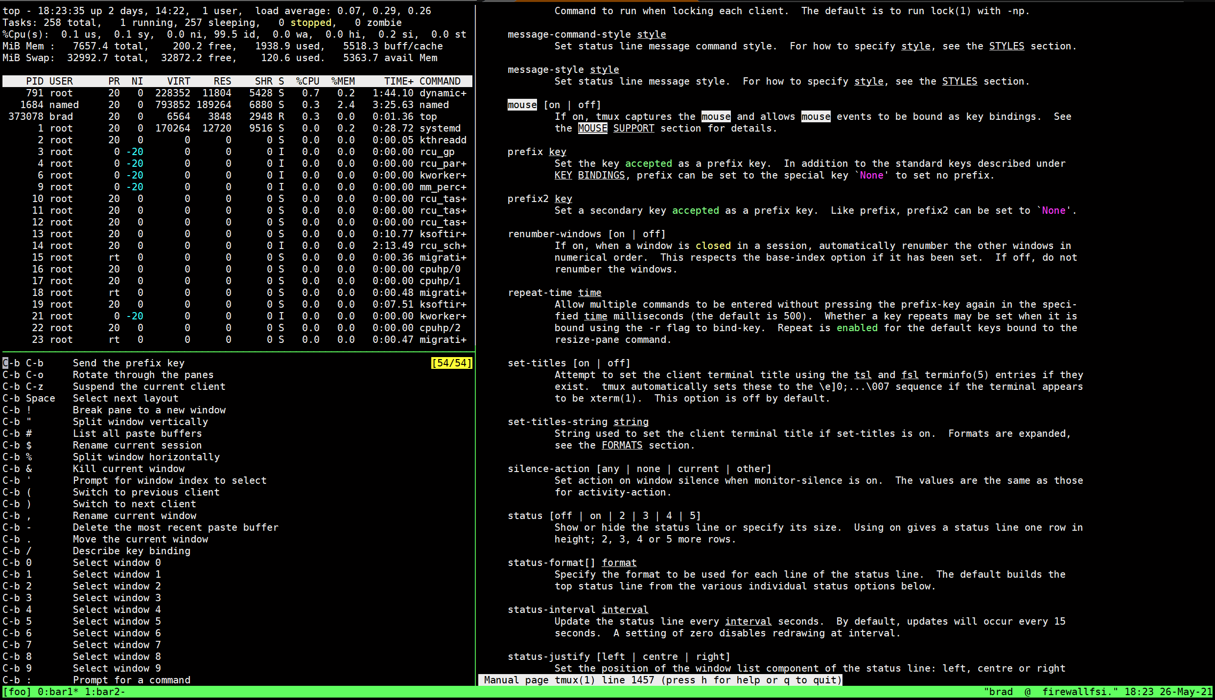
- To detach from a session: <prefix> d
- To reattach to a session: tmux a -t foo
- To list your sessions: tmux ls
- To split a window vertically: <prefix> %, split horizontally with <prefix> ”. And unlike screen, splitting in tmux automatically gives you a new shell prompt!
  - Navigate around splits (called panes) with <prefix> followed by an arrow key
(←, →, ↑, ↓) or by using the pane # (0-9) with <prefix> q <pane-number>
- To create a new window: <prefix> c
  - Name your window: <prefix> ,
  - Switch to window: <prefix> [0-9]
- To list all 54 prefix commands: <prefix> ?
- For mouse support (don’t lol – Brad uses it!):
set-option mouse on
Although Troy and Brad are still relatively new to tmux(1), it has quickly proven to be a better fit for their workflows. If you have your splits and windows set-up as you like them, and you detach and re-attach to the session, it’s going to look exactly as you left it. This was not something easily configured in screen – as screen will still have all of your processes open, but you would have to recreate all of your splits again.
Auto state saving, server restoring, and many other additional capabilities are accomplished with plugins and are an easy one-line add to your tmux.conf.
Perhaps a MUUG RTFM is in the future plans!
Troy and Brad invite you to check out tmux(1) over the summer.
To help you in your tmux(1) journey: https://tmuxcheatsheet.com/
Major KDE Productivity Boost!
KCommandBar coming for all KDE Applications
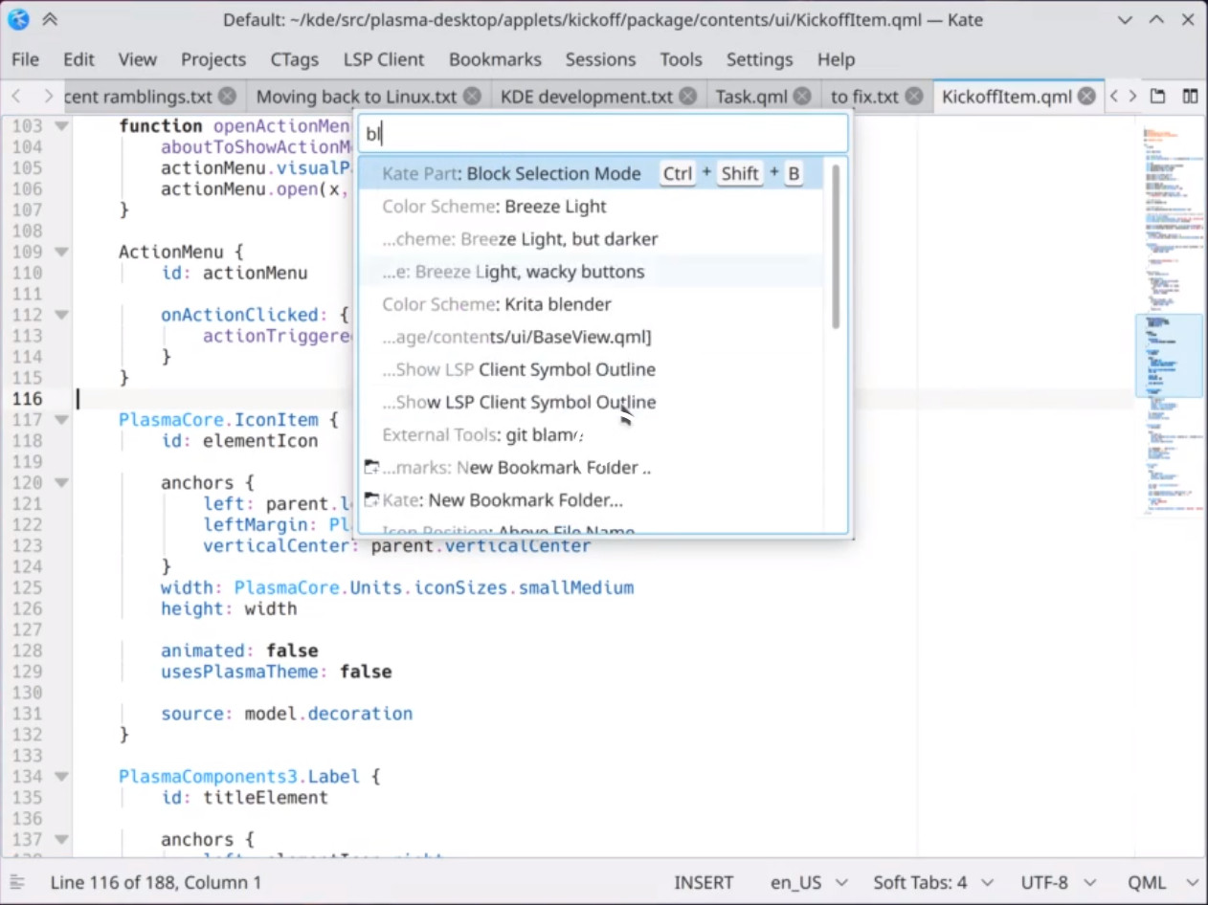
A new HUD-Style pop-up menu called KCommandBar has been introduced by the KDE team that will change the game on how you interact with KDE apps..
“HUD-Style” Pop-up menus are trending and it seems everyone is introducing it. LibreOffice introduced a similar pop-up Command Search option in version 7.2 (which is in currently in the development release). Now, KDE users, will have a feature which can bring automatic hud-style feature search inside all KDE Applications.
The KCommandBar pops up a text-based searchable window when activated. You can search all actions of that application and the results can be invoked immediately. It’s like a KRunner inside applications. Now there is no need to remember all the shortcuts, menu items, or options. All you need to do is launch KCommandBar and type your desired option and launch.
This feature is automatically introduced in all KDE applications that use QWidgets and the KXMLGui framework, which is almost all major KDE apps. So, basically, all of your old apps suddenly get a feature boost!
Along with this feature, many bug fixes and updates are pouring in for the upcoming KDE Plasma 5.22 release. Major updates include adaptive transparency in panels, audio applet improvements, offline updates, and more.
KDE Plasma 5.22 is due to release in June 2021.
This is why, some say, KDE Plasma, is by far the most advanced Linux Desktop today. With all these productive feature landings and the best developer around, maybe one day KDE Plasma will conquer the Linux Desktop user base.

Help us promote this month's meeting, by putting this poster up on your workplace bulletin board or other suitable public message board:

https://muug.ca/meetings/MUUGmeeting.pdf
Sublime Text 4 is Here!
By Bradford Vokey

This editor’s favourite GUI text/code editor just received a major update. Although Sublime Text is not open source, as I have shown by using it in many of my MUUG demos over the years, it may be downloaded and evaluated for free with no enforced time limit for the evaluation. As such, it is basically “shareware”. I went 4 years “evaluating” Sublime Text 2 (2014-2018) before finally purchasing a license for Sublime Text 3, in 2018. Packages are provided for most of the major Linux distributions, as well as installers for Windows and Mac.
Sublime Text was certainly one of the most popular GUI code editors back in 2014 (equalling the popularity of Vim, Emacs, and VS Code, according to Google Trends) and although it has fallen out of popularity since then, it still ticks all the boxes for me in 2021. Most importantly, it is lightning fast and super stable. It is a lightweight text editor with powerful IDE-like features, and allows you to customize almost everything to your liking!
Some of the updates I am looking forward to in Sublime Text 4:
- Tab Multi-Select: Split views have become even more effortless, with support throughout the interface (and commands) to show and hide split views based on context. The sidebar, tabs, Goto Anything, Goto Definition, and auto complete have all been tweaked with split view ability to make code navigation easier and more intuitive than ever.
- More Context-Aware Auto Complete: The auto complete engine has been rewritten to provide even more smart completions based on the existing code in your entire project, augmented with info about what kind of auto completion it is along with links to your actual definitions in your own code.
- Super-powered Syntax Highlighting: Now handles non-deterministic grammars, multi-line constructs, lazy embeds and syntax inheritance. Plus memory usage has been reduced, and load times are faster than ever.
- GPU Rendering: Sublime Text 4 can now render your interface using your GPU on Linux, Windows, and Mac (even native M1!). This results in even faster performance while using less CPU power than ever before.
For detailed information, feature demos, or to give it a test drive over the summer, head on over to:

https://www.sublimetext.com/
This old programmer fully recommends it!
Thank You Les.net
A continued thank you to LES.net for providing MUUG free hosting and bandwidth for our server and mirror.

https://les.net/
Les.net (1996) Inc. is a local provider of VoIP, Internet and Data Centre services. Contact sales@les.net or call 204-944-0009.
Thank You Michael W. Lucas

MUUG would like to thank Michael W. Lucas for donating one of his ebooks every month as a door prize. You can view and purchase his tech books here:

https://www.tiltedwindmillpress.com/product-category/tech/
Creative Commons License

Except where otherwise noted, all content in this newsletter is licensed under a Creative Commons “Attribution-ShareAlike 2.5 Canada” License.
http://creativecommons.org/licenses/by-sa/2.5/ca/deed.en_CA

