MUUGLines
The Manitoba UNIX User Group Newsletter

Volume 32 No. 4, December 2019 Editor: Bradford C. Vokey
Next Meeting: December 10th, 2019
As 2019 draws to a close, MUUG continues our recent tradition of turning the December meeting into more of a social event. Bring your favourite gadget! We will have the usual (brief) round-table session, followed by a short presentation, a gadget show & tell, and then have some time for mingling, eating, and drinking.

Main Presentation:
UNIX@50 (A Personal History)
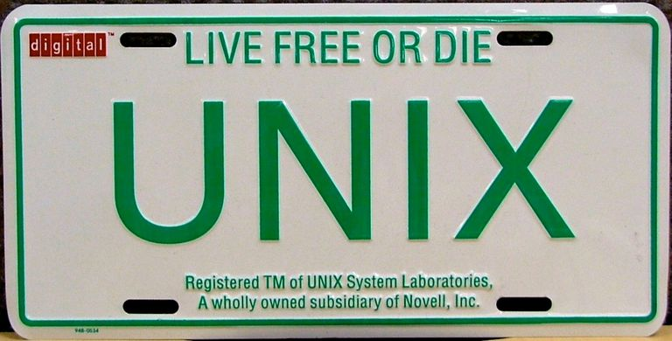

UNIX turned 50 this past summer. Gilbert Detillieux has worked with UNIX systems for the last 40 of those 50 years. In this not-too-technical presentation, Gilbert will take you through 5 decades of UNIX evolution (with some personal reflections on the last 4 of those decades). Come for the interesting trivia, stay for the philosophical musings!

Bring your favorite gadget
Bring your latest gadget to talk about—while everyone mingles, eats, and drinks.
This will be a pot-luck snack event

Members are encouraged to bring their own food to sample and share with others. Feel free to bring your own special drink as well – just remember that we don't have a liquor license!
Where to Find the Meeting:


University of Winnipeg,
Room 1L06 Lockhart Hall
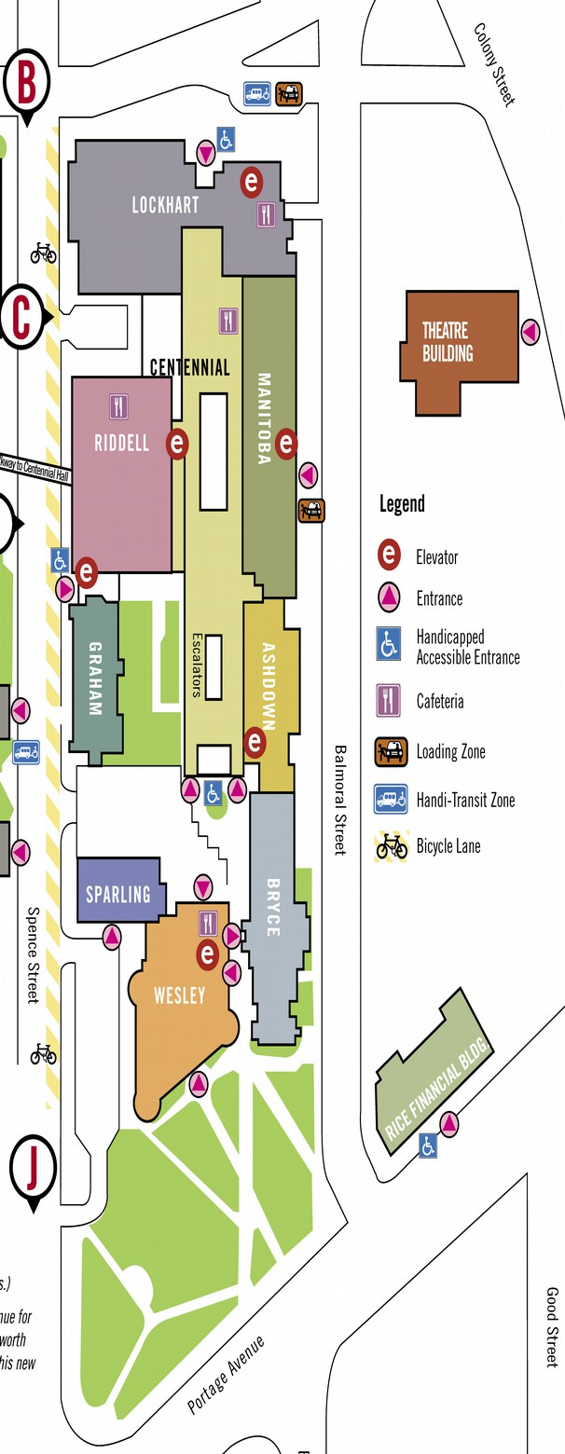
This month we have been moved to the University of Winnipeg's Lockhart Hall, on the north side of the University Complex. Closest entrance is on Ellice Avenue, between Spence and Balmoral.
We can be found in room 1L06.
Wyatt Zacharias
Doors are usually open by 7:00 pm with the meeting starting at 7:30 pm. Parking is available on the surrounding streets. See uwinnipeg.ca/maps for further information about parking and access to the campus.
Food Bank Donations Requested

As in previous years, we are combining our pot luck with a food drive for Winnipeg Harvest.
Cash donations are preferred as every $1 Winnipeg Harvest receives, they are able to pick up and deliver $20 worth of groceries.
Any member who donates at least $1 or brings at least 1 food item will be given an entry into the door prize!
Top 10 Most-Wanted Food Items
1. Canned Fish & Poultry | 6. Baby Formula & Food
2. Canned Fruit & Vegetables | 7. Rice
3. Canned Stew, Chili, Brown Beans | 8. Canned Spaghetti Sauce
4. Peanut Butter | 9. Cereal
5. Whole Grain Pasta | 10. Canned Soup
Meet Your New Board
The MUUG Board for the 2019-2020 year was elected by acclamation at the November general meeting.

Your board now consists of 9 members:
- Trevor Cordes
- Troy Denton
- Gilbert Detillieux
- Kevin McGregor
- Katherine Scrupa
- Adam Thompson
- Tyhr Trubiak
- Brad Vokey
- Wyatt Zacharias
A big thank you to all the nominees who let their names stand for election and an even bigger thank you to Troy Denton for joining the board this year!
Board Positions
Your new board held their first board meeting on November 19th, and for the 5th year in a row they elected the same executive officers.
Long live the BDFL!
President: Wyatt Zacharias
Vice-President: Trevor Cordes
Secretary: Gilbert Detillieux
Treasurer: Brad Vokey

Your banking committee is still made up of Brad Vokey, Gilbert Detillieux and Kevin McGregor and the server committee is still made up of Adam Thompson, Katherine Scrupa, and Wyatt Zacharias.

The new board looks forward to serving you over the next year. If you have any questions or requests, feel free to send an email to <board@muug.ca>.
December Door Prizes:
This month, bring a cash donation (or any food item) for Winnipeg Harvest to be eligible for the prize draws.
Along with our usual e-book give away this month we will also be giving away the printed books:

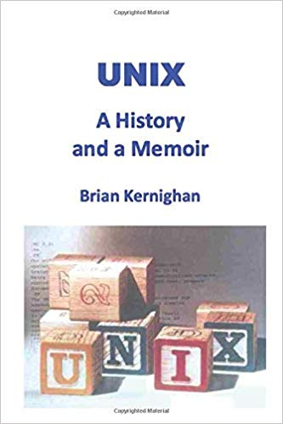
UNIX
A History and a Memoir
Release Date: October 18, 2019
Pages: 197
The fascinating story of how Unix began and how it took over the world. Brian Kernighan was a member of the original group of Unix developers, the creator of several fundamental Unix programs, and the co-author of classic books like “The C Programming Language” and “The Unix Programming Environment.”


Rails Crash Course
A No-Nonsense Guide to Rails Development
Publisher: No Starch Press
Release Date: October 2014
Pages: 296
Rails is a robust, flexible development platform that lets you build complex websites quickly. Major websites like GitHub, Hulu, and Twitter have run Rails under the hood, and if you know just enough HTML and CSS to be dangerous, Rails Crash Course will teach you to harness Rails for your own projects and create web applications that are fast, stable, and secure.
Each chapter is packed with hands-on examples and exercises to reinforce what you’ve learned. Whether you’re completely new to Ruby or you’ve been mucking around for a bit, Rails Crash Course will take you from the basics to shipping your first Rails application, fast.
MUUG Annual Financial Statements

By Bradford C. Vokey, MUUG treasurer
Here are your MUUG 2018-2019 annual financial statements.
Our membership grew by 1 member last year to a total of 51 paying members.
Our server and mirror have now been officially written off which will now allow us to commit more resources to help improve its performance in the near future. Your board is continuing to slowly and carefully use our built up surplus to help serve the *nix community here in Manitoba.
As per our bylaws (11.(h)) “The books and records of MUUG may be inspected by any member at the Annual Meeting or at any time upon not less than fourteen days notice in writing to the Executive.”


Tee Time
a quick beginner RTFM by Bradford C. Vokey
I often come across basic Unix commands that almost seem too simple to be useful. But then you start using it and you just admire how easy they solve your basic problem. Tee(1) is one of those!
Tee simply reads from standard input and writes to standard output and files.
tee [OPTION]... [FILE]...
It has 2 basic options:
-a, --append
append to the given FILEs, do not overwrite
-i, --ignore-interrupts
ignore interrupt signals
So what basic (common) problem does this solve for me? I often have a long running Perl script that I want to capture the output into a log file but at the same time monitor what the script is doing. Does that sound familiar to anyone? My solution (until this very month – and finally using tee – doh), was to redirect the output to the log file and then tail -f the log file to monitor the output. Now I just pipe to tee and do both in one step!
Here is an example using ping:
ping fsi.ca | tee logfile
This will output the normal output of ping to stdout at the same time as saving it to logfile. Simple and useful.
Add some tee to your next terminal session!
Solve puzzles using Unix pipes

Part of the Nokia Bell Labs 50th anniversary website has a cool little gaming page called “The Unix Game”. It is a fun, low-barrier programming contest using UNIX text processing utilities. Rise to the challenge and compare your progress with other players
https://www.unixgame.io/unix50
$1,000 worth of Free Credit Card Processing!

Ever wanted to start accepting credit cards for your own needs?
Now it's FREE!
Sign up with Square (the credit card processor that MUUG uses at our monthly meetings) with the referral link below and both you and MUUG will receive $1,000 in free processing for the next 6 months (180 days).
You must use the following referral link for MUUG to receive the credit:

https://squareup.com/i/MANITOBAU1
Thank You Les.net

A big thanks to LES.net for providing MUUG with free hosting and all that bandwidth!

https://les.net/
Creative Commons License

Except where otherwise noted, all content in this newsletter is licensed under a Creative Commons “Attribution-ShareAlike 2.5 Canada” License.
http://creativecommons.org/licenses/by-sa/2.5/ca/deed.en_CA

Help us promote this month's meeting, by putting this poster up on your workplace bulletin board or other suitable public message board:

https://muug.ca/meetings/MUUGmeeting.pdf

