
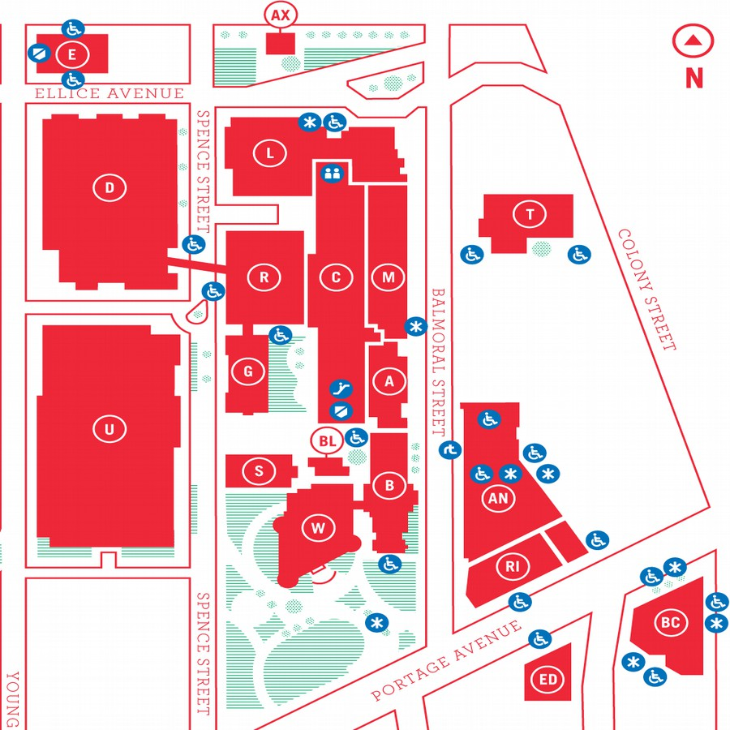
MUUGLines
The Manitoba UNIX User Group Newsletter
Volume 28 No. 1, September 2015 Editor: Bradford C. Vokey
Next Meeting: September 8th, 2015, 7:30 pm

Main Topic

This month Wyatt Zacharias will be presenting Spacewalk, an open source systems management tool. Spacewalk allows administrators to deploy, manage, configure, and monitor their enterprise Linux hosts. Spacewalk also provides update management, security scans, and more.

RTFM

In the RTFM segment this month, Rob Keizer will be showing us Homebrew (brew(1)). Homebrew is the easiest and most flexible way to install the UNIX tools that Apple didn’t include with OS X.

Door Prize

This month we will be giving away (among our other usual prizes) a ticket to Bsides Winnipeg 2015.
Security BSides is a global, non-profit organization that exists to facilitate the creation of local information security conferences. These conferences are ideally organized by locals, and feature local presenters. Unlike other conferences, BSides events are low-cost, relaxed, and inclusive and attempt to encourage interaction amongst organizers, speakers, and attendees.
BSides Winnipeg 2015 will take place on November 14th & 15th, 2015 at The King’s Head Pub from Noon to 7pm. Cost is $20 and comes with a meal each day.
Where to Find the Meeting
As of August 28th, we have still not been assigned a meeting room for the new academic year.
Meetings are usually held in the University of Winnipeg’s Lockhart Hall (marked “L” on the map), at the south-east corner of Spence Street and Ellice Avenue. We can normally be found in room 1L08, but occasionally get relocated to nearby rooms. If there is a change, it will be conveyed via a sign on the door to 1L08. Doors are usually open by 7:00 pm with the meeting starting at 7:30 pm. Parking is available on the surrounding streets. Please see http://www.uwinnipeg.ca/maps for further information about parking and access to the campus.
We will post the meeting room number on the website as soon as we are assigned one.

https://www.muug.mb.ca/meetings/

Bcachefs, a new speed-focus Linux file system
Ex-Google engineer Kent Overstreet is developing a new file system for Linux called Bcache File System (Bcachefs). Right now he is looking for other like minded Linux developers to help him test it and suggest further modifications required.
With so many working file systems already available, Linux users may ask why create a new file system? On his blog, Overstreet explains the need for Bcache,
“Well, years ago (going back to when I was still at Google), I and the other people working on bcache realized that what we were working on was, almost by accident, a good chunk of the functionality of a full blown filesystem – and there was a really clean and elegant design to be had there if we took it and ran with it. And a fast one – the main goal of bcachefs to match ext4 and xfs on performance and reliability, but with the features of btrfs/zfs.”
“It’s taken a long time to get to this point – longer than I would have guessed if you’d asked me back when we first started talking about it – but I’m pretty damn proud of where it’s at now.”
Overstreet explained that the main goal of Bcachefs is to match the speed of the traditional Linux file systems (Ext4) with the advanced scalability and reliability of newer file systems such as Btrfs and XFS.
Over the years, need for speed and stability has caused many organizations and users to move towards other file systems, such as Btrfs or XFS which can handle very large amounts of data, or to use advanced techniques in ensuring data integrity.
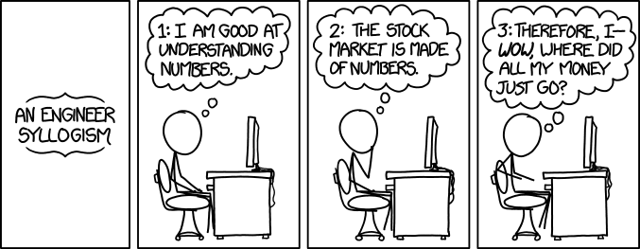
Overstreet says Bcachefs will solve all these problems because it will come with all the modern capabilities one would expect from a Copy on Write file system with features such as checksum, compression, support for multiple storage devices and caching. Another feature will be erasure coding, which is a method of writing data across the disk in multiple locations so it can be reassembled should bits of the data get corrupted and can’t be read. Overstreet says that Bcachefs is in development mode and “all kinds of other nifty features,” will be added soon.
A timely reminder regarding the recent stock market turmoil...

From xkcd: http://xkcd.com/1570/
Overstreet showed the benchmark results of the new file system with Bcachefs delivering compelling throughput compared to ext4 and significantly faster speeds than btrfs in most instances.
There are a still a number of limitations of the new software, Overstreet pointed out. For one, the file system requires about 20% of the disk to perform operations. Also, the time it takes to mount the file system, or make it available to an operating system, may take longer than other file systems.
“My main priority is getting the code sufficiently stable and tested for production use, probably the #2 priority is snapshots,” concluded Overstreet. “Bcachefs won’t be done in a month (or a year), but I do want to see it out there and getting used.”
Overstreet has invited Linux developers to try it out to find bugs and also suggest any modifications.
More on bcache and bcachefs:
http://bcache.evilpiepirate.org/
Original article: http://www.techworm.net/2015/08/ex-google-engineer-unveils-bcache-new-file-system-for-linux.html

MUUG Has A New Mailing Address

After more than 27 years MUUG has finally decided that renting a PO BOX for our physical mail is no longer justified (sorry Canada Post). Our new mailing address is now:
Manitoba UNIX User Group
c/o Gilbert Detillieux
Computer Science, E2-445 EITC
University of Manitoba
Winnipeg MB R3T 2N2
Command One-Liners
Here is an interesting compilation for command line one-liners compiled by Arturo Herrero from the UK:
github.com/arturoherrero/command-line-one-liners
Here are some of the ones I found interesting. They may be old hat for some of you!
Quickly rename a file
$ mv filename.{old,new}
$ mv filename.{png,jpg}

Create a quick back-up copy of a file
$ cp file.txt{,.bak}

Make less behave like tail -f
$ less +F somelogfile

Create a script of the last executed command
$ echo "!!" > script.sh

Runs previous command but replacing typos
$ echo no typos
$ ^typos^errors

Escape any command aliases
$ alias ls="ls -a"
$ \ls

Make a directory creating intermediate directories
$ mkdir -p a/long/directory/path

Execute a command at a given time
$ echo "ls -l" | at midnight

Simple stopwatch
$ time read
<ctrl-d>

Quick access to the ascii table
$ man ascii

Display a calendar
$ cal 12 1984

What date was it yesterday or will it be tomorrow, etc...
$ date -d yesterday
$ date -d tomorrow +%Y-%m-%d
$ date -d "7 days ago" +%Y-%m-%d


Nostalgy
Thunderbird Extension
a recommendation by Bradford C. Vokey
Nostalgy is an extension for Mozilla Thunderbird whose purpose is to save time by doing more operations with the keyboard. If you want to use Thunderbird without sacrificing the productivity you had with good old mutt/pine, this extension is for you!
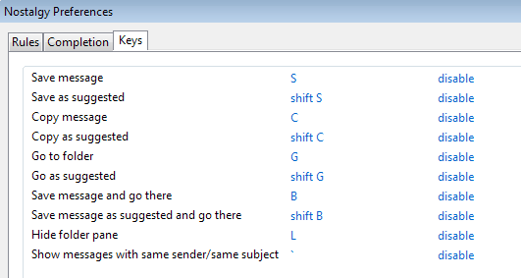
Nostagly adds keyboard shortcuts to change your current folder view and to move/copy messages, all with folder name auto-completion.
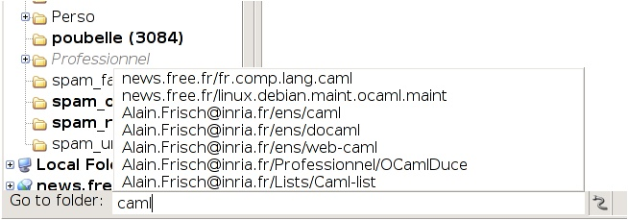
It also has a system of rules to help suggest a target folder for saving messages; facilitates keyboard navigation in the 3-pane window; makes it easy to change between To/Bcc/Cc fields in the composer; and facilitates tag operations. All with the keyboard only!

I use it everyday to organize my email and get it down to inbox zero. Yes I am one of those guys.
addons.mozilla.org/en-us/thunderbird/addon/nostalgy/
Creative Commons License

Except where otherwise noted, all content in this newsletter is licensed under a Creative Commons “Attribution-ShareAlike 2.5 Canada” License.
http://creativecommons.org/licenses/by-sa/2.5/ca/deed.en_CA
MUUG has gone social!
For better or worse, you can now find (and follow!) MUUG on some social platforms. Get interactive and share all about MUUG on social media.

Twitter:
twitter.com/manitobaunix

Facebook:
facebook.com/ManitobaUnix

MeetUp:
meetup.com/Manitoba-UNIX-User-Group
Spread The Word!
Do you have a friend or co-worker that has shown an interest in Unix, Linux, BSD, etc?
Bring them along to a meeting or at least tell them about us. The more the merrier!
Share Your Thoughts

Please email MUUG with your comments and suggestions regarding the newsletter and the meetings. Whether it’s criticisms or commendations, we want to hear from you. Specifically, what sort of material would you like to see and or hear/about.
Also, if you have a How-To or any other idea (and aren’t ready to give a presentation at MUUG), an article is a great alternative! If you can write better than the editor(s), that’s terrific; if you can’t, submit it anyway and we’ll get it into shape for publication. We know that many of you have some great ideas and lots of knowledge. Why not share?
Send an email to: editor@muug.mb.ca.

