
MUUGLines
The Manitoba UNIX User Group Newsletter
Volume 27 No. X, Month 2014 Editor: Your Name Here
Next Meeting: Month XXth, 2014

RTFM and presentation:
Brief topic abstract.
For this month’s RTFM topic, So And So will talk about the Such And Such command.
Where to Find the Meeting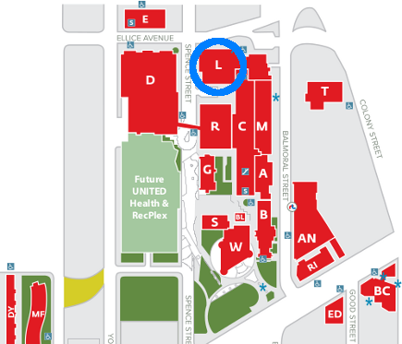
University of Winnipeg Lockhart Hall (marked “L” on the map), on the south-east corner of Spence and Ellice. Parking is available on the surrounding streets. Meetings are normally in room 1L08, but occasionally are relocated to nearby rooms. If there is a change, it should be conveyed via a sign on the door to 1L08.
MUUG Mugs!
Back by popular demand! MUUG now has new coffee mugs, laser-etched with our age old, lovable logo for sale for $15 cash. There are a limited number available, so get yours at the next meeting!
Creative Commons License
Except where otherwise noted, all content in this newsletter is licensed under a Creative Commons “Attribution-ShareAlike 2.5 Canada” License.

http://creativecommons.org/licenses/by-sa/2.5/ca/deed.en_CA
Section Headings Use
MUUG-heading 2 Style

Sub-sections Use MUUG-heading 3
Body-copy text uses MUUG-Body style.

http://example.com/MUUG-Link
Book Discounts

No Starch Press has established a discount for user group members. It's valid for 30% off everything they publish, and it doesn't expire. Use “MUUG” as the discount code when ordering from their website.

http://www.nostarch.com/

